**Practical No 8**

**a. Create a web application for inserting and deleting records from a database. (Using Execute Non Query).**

**aspx code:**

<%@ Page Language="C#" AutoEventWireup="true" CodeBehind="WebForm1.aspx.cs" Inherits="practical8pract.WebForm1" %>

<!DOCTYPE html>

<html xmlns="http://www.w3.org/1999/xhtml">

<head runat="server">

<title></title>

<style type="text/css">

.auto-style1 {

height: 752px;

width: 607px;

margin-left: 184px;

}

.auto-style2 {

position: absolute;

top: 37px;

left: 330px;

z-index: 1;

width: 337px;

}

.auto-style3 {

position: absolute;

top: 130px;

left: 278px;

z-index: 1;

}

.auto-style4 {

position: absolute;

top: 189px;

left: 275px;

z-index: 1;

}

.auto-style5 {

position: absolute;

top: 246px;

left: 297px;

z-index: 1;

height: 23px;

}

.auto-style6 {

position: absolute;

top: 305px;

left: 258px;

z-index: 1;

}

.auto-style7 {

position: absolute;

top: 421px;

left: 285px;

z-index: 1;

}

.auto-style8 {

position: absolute;

top: 536px;

left: 291px;

z-index: 1;

height: 28px;

}

.auto-style9 {

position: absolute;

top: 139px;

left: 391px;

z-index: 1;

width: 204px;

height: 25px;

}

.auto-style10 {

position: absolute;

top: 194px;

left: 393px;

z-index: 1;

width: 205px;

height: 25px;

}

.auto-style11 {

position: absolute;

top: 249px;

left: 395px;

z-index: 1;

width: 203px;

height: 25px;

}

.auto-style12 {

width: 130px;

height: 27px;

position: absolute;

top: 311px;

left: 396px;

z-index: 1;

right: 493px;

}

.auto-style14 {

width: 161px;

height: 27px;

position: absolute;

top: 407px;

left: 392px;

z-index: 1;

}

.auto-style15 {

position: absolute;

left: 398px;

z-index: 1;

top: 536px;

}

.auto-style16 {

position: absolute;

top: 608px;

left: 680px;

z-index: 1;

right: 248px;

}

.auto-style17 {

position: absolute;

top: 682px;

left: 684px;

z-index: 1;

width: 93px;

}

.auto-style18 {

position: absolute;

top: 667px;

left: 321px;

z-index: 1;

width: 239px;

}

</style>

</head>

<body>

<form id="form1" runat="server">

<div class="auto-style1" style="border: thick double #0000FF">

<asp:Label ID="Label1" runat="server" BorderStyle="Solid" CssClass="auto-style2" Font-Bold="True" Font-Size="XX-Large" Text="Registration Form"></asp:Label>

<asp:Label ID="Label2" runat="server" CssClass="auto-style3" Font-Bold="True" Font-Size="X-Large" Text="Name : "></asp:Label>

<asp:Label ID="Label3" runat="server" CssClass="auto-style4" Font-Bold="True" Font-Size="X-Large" Text="Email :"></asp:Label> <asp:Label ID="Label4" runat="server" CssClass="auto-style5" Font-Bold="True" Font-Size="X-Large" Text="Age :"></asp:Label>

<asp:Label ID="Label5" runat="server" CssClass="auto-style6" Font-Bold="True" Font-Size="X-Large" Text="Gender : "></asp:Label>

<asp:TextBox ID="TextBox3" runat="server" BorderStyle="Solid" CssClass="auto-style11"></asp:TextBox>

<asp:TextBox ID="TextBox2" runat="server" BorderStyle="Solid" CssClass="auto-style10"></asp:TextBox>

<asp:RadioButtonList ID="RadioButtonList1" runat="server" CssClass="auto-style12" Font-Bold="True" Font-Size="X-Large">

<asp:ListItem>male</asp:ListItem>

<asp:ListItem>Female</asp:ListItem>

</asp:RadioButtonList>

<asp:TextBox ID="TextBox1" runat="server" BorderStyle="Solid" CssClass="auto-style9"></asp:TextBox>

<asp:CheckBoxList ID="CheckBoxList1" runat="server" CssClass="auto-style14" Font-Bold="True" Font-Size="X-Large">

<asp:ListItem>devloper</asp:ListItem>

<asp:ListItem>adviser</asp:ListItem>

<asp:ListItem>designer</asp:ListItem>

</asp:CheckBoxList>

<asp:Label ID="Label7" runat="server" CssClass="auto-style8" Font-Bold="True" Font-Size="X-Large" Text="City :"></asp:Label>

<asp:Label ID="Label6" runat="server" CssClass="auto-style7" Font-Bold="True" Font-Size="X-Large" Text="Skill : "></asp:Label>

<asp:DropDownList ID="DropDownList1" runat="server" CssClass="auto-style15" Font-Bold="True" Font-Size="X-Large">

<asp:ListItem>Dodamarg</asp:ListItem>

<asp:ListItem>Sawantwadi</asp:ListItem>

<asp:ListItem>Vengurla</asp:ListItem>

<asp:ListItem>Kudal</asp:ListItem>

<asp:ListItem>kankavli</asp:ListItem>

</asp:DropDownList>

<asp:Button ID="Button1" runat="server" BorderStyle="Solid" CssClass="auto-style16" Font-Bold="True" Font-Size="X-Large" Height="43px" Text="Insert" Width="93px" OnClick="Button1_Click" />

<asp:Button ID="Button2" runat="server" BorderStyle="Solid" CssClass="auto-style17" Font-Bold="True" Font-Size="X-Large" OnClick="Button2_Click" Text="Viev" />

<asp:Label ID="Label8" runat="server" CssClass="auto-style18" Font-Bold="True" Font-Size="XX-Large"></asp:Label>

</div>

</form>

</body>

</html>

**C# code :**

using System;

using System.Collections.Generic;

using System.Linq;

using System.Web;

using System.Web.UI;

using System.Web.UI.WebControls;

using System.Data;

using System.Data.SqlClient;

using System.Configuration;

using System.Data;

namespace practical8pract

{

public partial class WebForm1 : System.Web.UI.Page

{

SqlConnection con = new SqlConnection(ConfigurationManager.ConnectionStrings["ConnectionString"].ConnectionString);

protected void Page_Load(object sender, EventArgs e)

{

}

protected void Button2_Click(object sender, EventArgs e)

{

Response.Redirect("WebForm2.aspx");

}

protected void Button1_Click(object sender, EventArgs e)

{

SqlCommand cmd1 = new SqlCommand("insert into registration VALUES (@name, @email, @age, @gender, @skill, @city)", con);

cmd1.Parameters.AddWithValue("@name", TextBox1.Text);

cmd1.Parameters.AddWithValue("@email", TextBox2.Text);

cmd1.Parameters.AddWithValue("@age", Convert.ToInt32(TextBox3.Text));

cmd1.Parameters.AddWithValue("@gender", RadioButtonList1.SelectedValue);

cmd1.Parameters.AddWithValue("@skill", CheckBoxList1.SelectedValue);

cmd1.Parameters.AddWithValue("@city", DropDownList1.SelectedValue);

con.Open();

cmd1.ExecuteNonQuery();

Label8.Text = "Data inserted successfully";

con.Close();

}

}

}

**Output:**

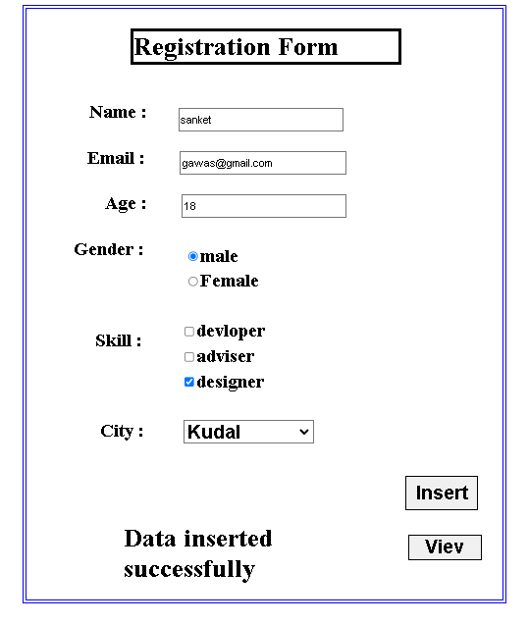

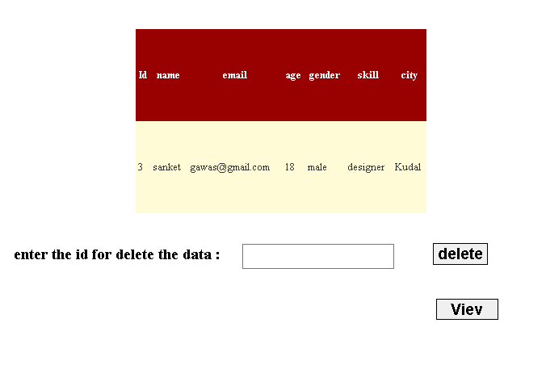

**View Records:**

**Delete code :**

**Aspx code :**

<%@ Page Language="C#" AutoEventWireup="true" CodeBehind="WebForm1.aspx.cs" Inherits="practical8pract.WebForm1" %>

<!DOCTYPE html>

<html xmlns="http://www.w3.org/1999/xhtml">

<head runat="server">

<title></title>

<style type="text/css">

.auto-style1 {

height: 752px;

width: 607px;

margin-left: 184px;

}

.auto-style2 {

position: absolute;

top: 37px;

left: 330px;

z-index: 1;

width: 337px;

}

.auto-style3 {

position: absolute;

top: 130px;

left: 278px;

z-index: 1;

}

.auto-style4 {

position: absolute;

top: 189px;

left: 275px;

z-index: 1;

}

.auto-style5 {

position: absolute;

top: 246px;

left: 297px;

z-index: 1;

height: 23px;

}

.auto-style6 {

position: absolute;

top: 305px;

left: 258px;

z-index: 1;

}

.auto-style7 {

position: absolute;

top: 421px;

left: 285px;

z-index: 1;

}

.auto-style8 {

position: absolute;

top: 536px;

left: 291px;

z-index: 1;

height: 28px;

}

.auto-style9 {

position: absolute;

top: 139px;

left: 391px;

z-index: 1;

width: 204px;

height: 25px;

}

.auto-style10 {

position: absolute;

top: 194px;

left: 393px;

z-index: 1;

width: 205px;

height: 25px;

}

.auto-style11 {

position: absolute;

top: 249px;

left: 395px;

z-index: 1;

width: 203px;

height: 25px;

}

.auto-style12 {

width: 130px;

height: 27px;

position: absolute;

top: 311px;

left: 396px;

z-index: 1;

right: 493px;

}

.auto-style14 {

width: 161px;

height: 27px;

position: absolute;

top: 407px;

left: 392px;

z-index: 1;

}

.auto-style15 {

position: absolute;

left: 398px;

z-index: 1;

top: 536px;

}

.auto-style16 {

position: absolute;

top: 608px;

left: 680px;

z-index: 1;

right: 248px;

}

.auto-style17 {

position: absolute;

top: 682px;

left: 684px;

z-index: 1;

width: 93px;

}

.auto-style18 {

position: absolute;

top: 667px;

left: 321px;

z-index: 1;

width: 239px;

}

</style>

</head>

<body>

<form id="form1" runat="server">

<div class="auto-style1" style="border: thick double #0000FF">

<asp:Label ID="Label1" runat="server" BorderStyle="Solid" CssClass="auto-style2" Font-Bold="True" Font-Size="XX-Large" Text="Registration Form"></asp:Label>

<asp:Label ID="Label2" runat="server" CssClass="auto-style3" Font-Bold="True" Font-Size="X-Large" Text="Name : "></asp:Label>

<asp:Label ID="Label3" runat="server" CssClass="auto-style4" Font-Bold="True" Font-Size="X-Large" Text="Email :"></asp:Label>

<asp:Label ID="Label4" runat="server" CssClass="auto-style5" Font-Bold="True" Font-Size="X-Large" Text="Age :"></asp:Label>

<asp:Label ID="Label5" runat="server" CssClass="auto-style6" Font-Bold="True" Font-Size="X-Large" Text="Gender : "></asp:Label>

<asp:TextBox ID="TextBox3" runat="server" BorderStyle="Solid" CssClass="auto-style11"></asp:TextBox>

<asp:TextBox ID="TextBox2" runat="server" BorderStyle="Solid" CssClass="auto-style10"></asp:TextBox>

<asp:RadioButtonList ID="RadioButtonList1" runat="server" CssClass="auto-style12" Font-Bold="True" Font-Size="X-Large">

<asp:ListItem>male</asp:ListItem>

<asp:ListItem>Female</asp:ListItem>

</asp:RadioButtonList>

<asp:TextBox ID="TextBox1" runat="server" BorderStyle="Solid" CssClass="auto-style9"></asp:TextBox>

<br />

<asp:CheckBoxList ID="CheckBoxList1" runat="server" CssClass="auto-style14" Font-Bold="True" Font-Size="X-Large">

<asp:ListItem>devloper</asp:ListItem>

<asp:ListItem>adviser</asp:ListItem>

<asp:ListItem>designer</asp:ListItem>

</asp:CheckBoxList>

<asp:Label ID="Label7" runat="server" CssClass="auto-style8" Font-Bold="True" Font-Size="X-Large" Text="City :"></asp:Label>

<asp:Label ID="Label6" runat="server" CssClass="auto-style7" Font-Bold="True" Font-Size="X-Large" Text="Skill : "></asp:Label>

<asp:DropDownList ID="DropDownList1" runat="server" CssClass="auto-style15" Font-Bold="True" Font-Size="X-Large">

<asp:ListItem>Dodamarg</asp:ListItem>

<asp:ListItem>Sawantwadi</asp:ListItem>

<asp:ListItem>Vengurla</asp:ListItem>

<asp:ListItem>Kudal</asp:ListItem>

<asp:ListItem>kankavli</asp:ListItem>

</asp:DropDownList>

<asp:Button ID="Button1" runat="server" BorderStyle="Solid" CssClass="auto-style16" Font-Bold="True" Font-Size="X-Large" Height="43px" Text="Insert" Width="93px" OnClick="Button1_Click" />

<asp:Button ID="Button2" runat="server" BorderStyle="Solid" CssClass="auto-style17" Font-Bold="True" Font-Size="X-Large" OnClick="Button2_Click" Text="Viev" />

<asp:Label ID="Label8" runat="server" CssClass="auto-style18" Font-Bold="True" Font-Size="XX-Large"></asp:Label>

</div>

</form>

</body>

</html>

**C# code :**

using System;

using System.Collections.Generic;

using System.Linq;

using System.Web;

using System.Web.UI;

using System.Web.UI.WebControls;

using System.Data;

using System.Data.SqlClient;

using System.Configuration;

using System.Data;

namespace practical8pract

{

public partial class WebForm1 : System.Web.UI.Page

{

SqlConnection con = new SqlConnection(ConfigurationManager.ConnectionStrings["ConnectionString"].ConnectionString);

protected void Page_Load(object sender, EventArgs e)

{

}

protected void Button2_Click(object sender, EventArgs e)

{

Response.Redirect("WebForm2.aspx");

}

protected void Button1_Click(object sender, EventArgs e)

{

SqlCommand cmd1 = new SqlCommand("insert into registration VALUES (@name, @email, @age, @gender, @skill, @city)", con);

cmd1.Parameters.AddWithValue("@name", TextBox1.Text);

cmd1.Parameters.AddWithValue("@email", TextBox2.Text);

cmd1.Parameters.AddWithValue("@age", Convert.ToInt32(TextBox3.Text));

cmd1.Parameters.AddWithValue("@gender", RadioButtonList1.SelectedValue);

cmd1.Parameters.AddWithValue("@skill", CheckBoxList1.SelectedValue);

cmd1.Parameters.AddWithValue("@city", DropDownList1.SelectedValue);

con.Open();

cmd1.ExecuteNonQuery();

Label8.Text = "Data inserted successfully";

con.Close();

}

}

}

**Output :**

**Before the delete**

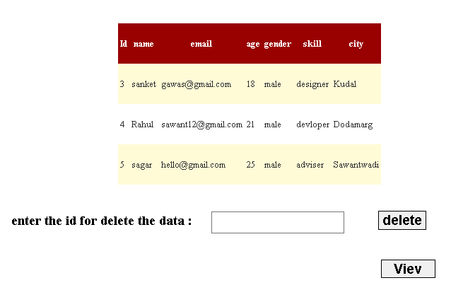

**After the delete :**

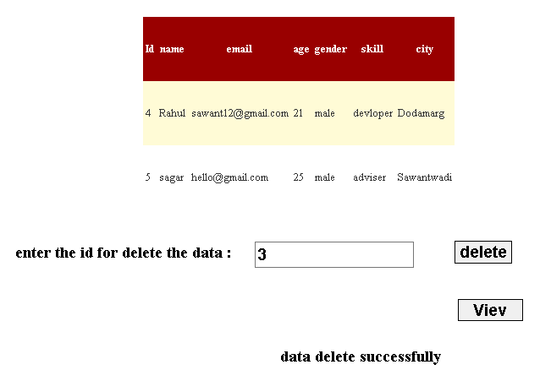

**b. Create a web application for user defined exception handling.**

**aspx code :**

<%@ Page Language="C#" AutoEventWireup="true" CodeBehind="WebForm1.aspx.cs" Inherits="pract8b.WebForm1" %>

<!DOCTYPE html>

<html xmlns="http://www.w3.org/1999/xhtml">

<head runat="server">

<title></title>

<center><h1>Check Voting Eligibility</h1></center>

</head>

<body>

<form id="form1" runat="server">

<div>

<asp:Label ID="Label1" runat="server" CssClass="auto-style3" Text="Enter Your Age"></asp:Label>

<asp:TextBox ID="TextBox1" runat="server" CssClass="auto-style1"></asp:TextBox>

</div>

<p>

<asp:Button ID="Button1" runat="server" CssClass="auto-style2" Text="check" OnClick="Button1_Click" />

</p>

<asp:Label ID="Label2" runat="server" CssClass="auto-style4" ForeColor="Red"></asp:Label>

</form>

</body>

</html>

**c# code:**

using System;

using System.Collections.Generic;

using System.Linq;

using System.Web;

using System.Web.UI;

using System.Web.UI.WebControls;

public class InvalidAgeException : Exception

{

public InvalidAgeException(string message) : base(message)

{

}

}

namespace pract8b

{

public partial class WebForm1 : System.Web.UI.Page

{

protected void Page_Load(object sender, EventArgs e)

{

}

protected void Button1_Click(object sender, EventArgs e)

{

try

{

int age = Convert.ToInt32(TextBox1.Text);

if (age < 18)

{

throw new InvalidAgeException("You are not eligible to vote. Minimum age is 18.");

}

Label2.Text = "You are eligible to vote!";

}

catch (InvalidAgeException ex)

{

Label2.Text = ex.Message;

}

catch (FormatException)

{

Label2.Text = "Please enter a valid number for age.";

}

catch (Exception ex)

{

Label2.Text = $"An error occurred: {ex.Message}";

}

}

}

}

**Output:**

